Notes:

UPS-HODGKINS TRANSPORTATION SCHEDULES

UPS
Chicago Area Consolidation Hub
7811 Willow Springs Rd. Hodgkins, IL 60525

Website: UPSJOBS.COM

This brochure list five bus schedules that arrive to and from the UPS Hodgkin’s facility. These public transportation schedules serve only as a guide and are sourced from pacebus.com (800) 606-1282 and
transitchicago.com (888) 968-7282. It is the Candidates responsibility to confirm arrival and departure times
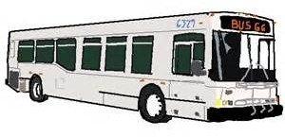
and locations.

